# Guide for Installing and Running SQLite

**CITS1402 - The University of Western Australia**

This guide outlines how to install SQLite and run it from the command line, i.e. Powershell on Windows or Terminal on MacOS (or Linux).

Update July 2023: In what follows, replace each occurrence of sqlite-tools-win32-x86-3390200.zip with the latest version sqlite-tools-win32-x86-3420000.zip.

## 1. Installing SQLite

### 1.1 Mac and Linux

If you are using Mac or Linux, SQLite should already be installed by default. You can skip ahead to **Section** **2 - Running SQLite via the Command Line.**

### 1.2 Windows

The installation of SQLite on Windows is a little trickier than installing most programs, as it does not come with an installer. It comes in the form of “precompiled binaries” (i.e. .exe files). In order to install it we need to download the binaries, and then add them to the Path so that we can run those binaries from anywhere on our computer in PowerShell.

**1.** First, head to the SQLite website and visit the downloads page at <https://www.sqlite.org/download.html>.

Click on “sqlite-tools-win32-x86-3390200.zip” to download the bundle of command-line tools, as highlighted below.

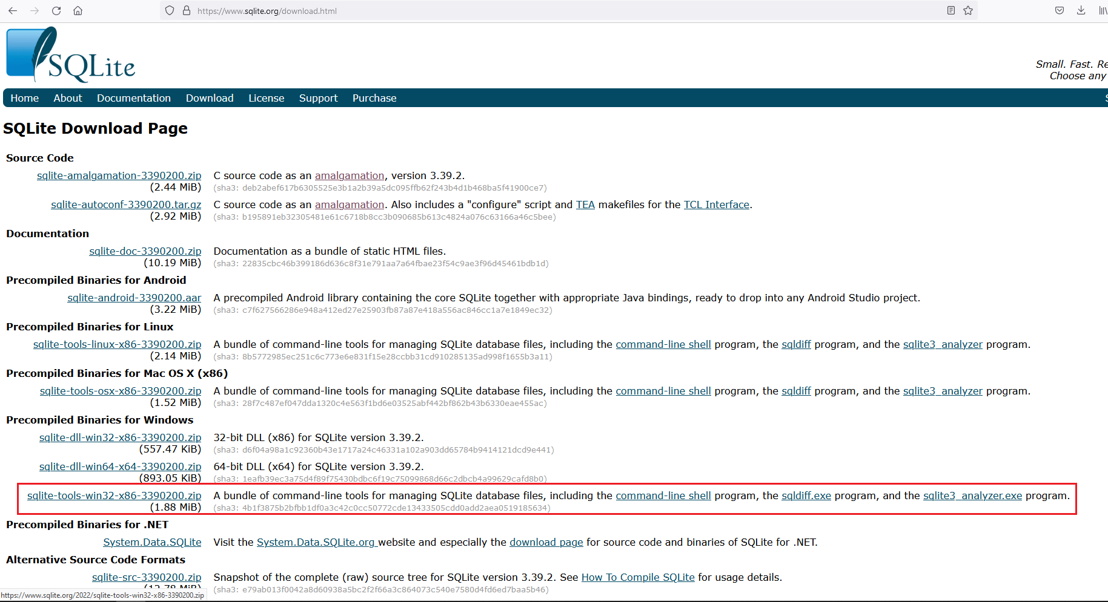

**2.** Once downloaded, right click on the downloaded zip file and select “Extract all”.

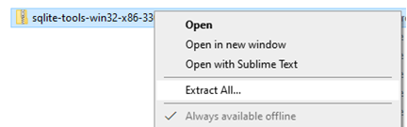

**3.** After extraction is complete, hover over the extracted folder. It should contain *sqldiff*, *sqlite3*, *sqlite3_analyzer* as shown below.

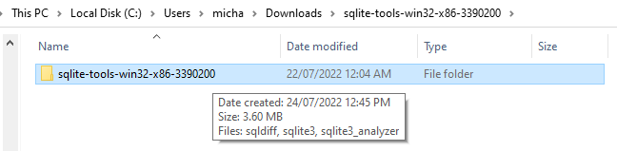

**4.** Copy the folder (Ctrl+C).

**5.** Paste the folder (Ctrl+V) somewhere you will remember, such as under Program Files or My Documents.

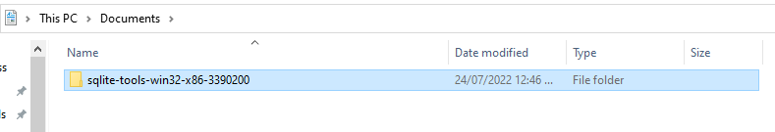

In order for Powershell to be able to find the location of SQLite, we need to add it to the “Path”. The Path is a list of directories where executable programs are located.

By adding SQLite to our Path, we will be able to open PowerShell anywhere on our computer and run SQLite. If we do not add it to the Path, PowerShell will report that ‘sqlite3 is not recognized’ when attempting to run it.

**6.** To add SQLite to the Path, we must first get its file location. Left click on the *sqlite-tools-win32-x86-3390200* folder, then hold down the Shift key, right click on the folder and click “Copy as path”.

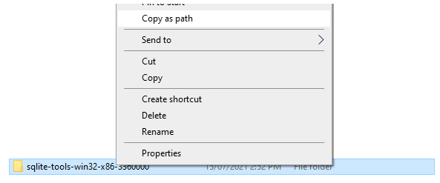

**7.** In the Windows Search Bar (bottom left), type in “Path”, and click on “Edit the system environment variables”. This will require administrator privileges.

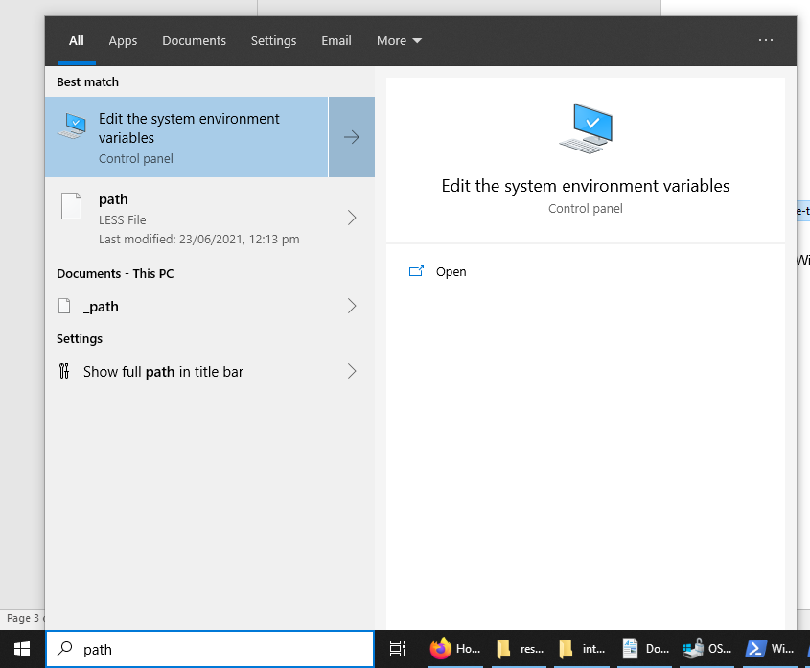

**8.** In the System Properties window that pops up, click on Environment Variables at the bottom.

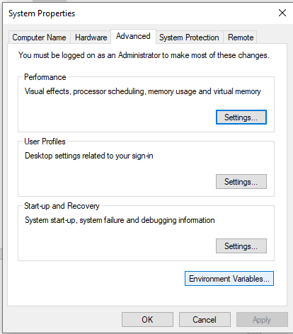

**9.** Click on “Path” under “User variables for <your username>” and click “Edit…”

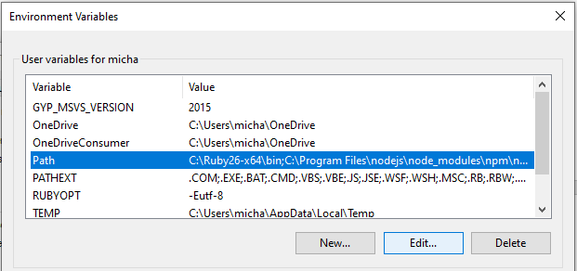

**10.** Click on “New” and paste in the path you copied back in Step 6.

Be careful not to edit other entries while doing this step.

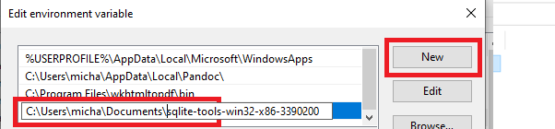

**11.** Click “OK” three times to close all the windows.

## 2.2 Running SQLite via the Command Line

Now that SQLite is installed and available in the Path we can run it via the command line, e.g. PowerShell.

**1.** Create a folder somewhere to store your SQLite databases, such as under My Documents. Double click to open the folder.

**2.** Holding down the shift key, right click somewhere in the white space to bring up the menu. Click on “Open PowerShell window here”. If you are using Mac or Linux, click on “Open in Terminal” instead.

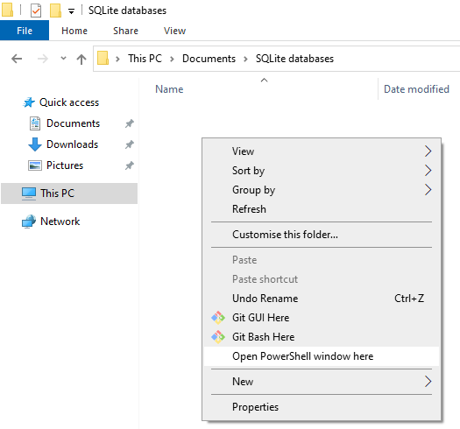

**3.** In PowerShell (or Terminal, if you are using Mac or Linux), type “sqlite3” (without quotes) and hit enter. This will start SQLite.

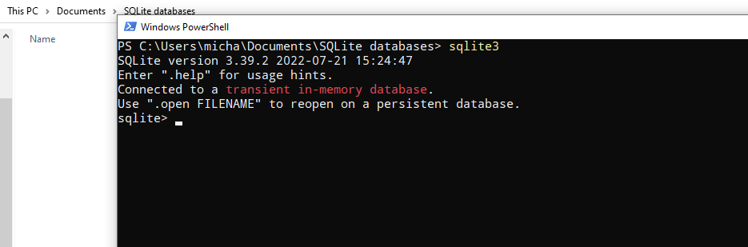

Any databases you create in SQLite will be stored the folder from which you opened PowerShell.

Remember to navigate back to this folder and run PowerShell from this folder (as per Step 2) whenever you want to access your databases.

**4.** Verify sqlite3 works correctly by creating a test database. Type in the following:

.open test.db

And press Enter. You should see a database file called ‘test’ pop up in your database folder.

